12.89: From symmetry, the component of the gravitational force parallel to the rod is zero. To find the perpendicular component, divide the rod into segments of length dx and mass 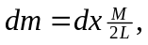 positioned at a distance x from the center of the rod. The magnitude of the gravitational force from each segment is
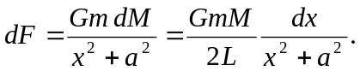
The component of dF perpendicular to the rod is dF 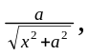 and so the net gravitational force is
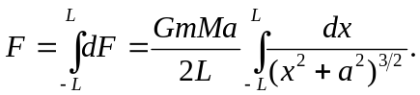
The integral can be found in a table, or found by making the substitution 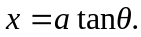 Then, and so
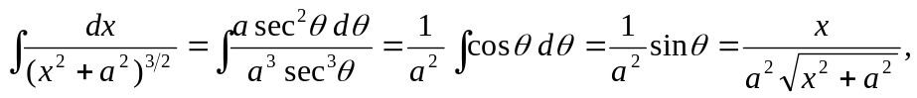
and the definite integral is
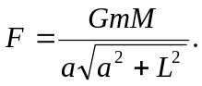
When a >> L, the term in the square root approaches 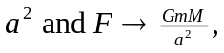 as expected.

